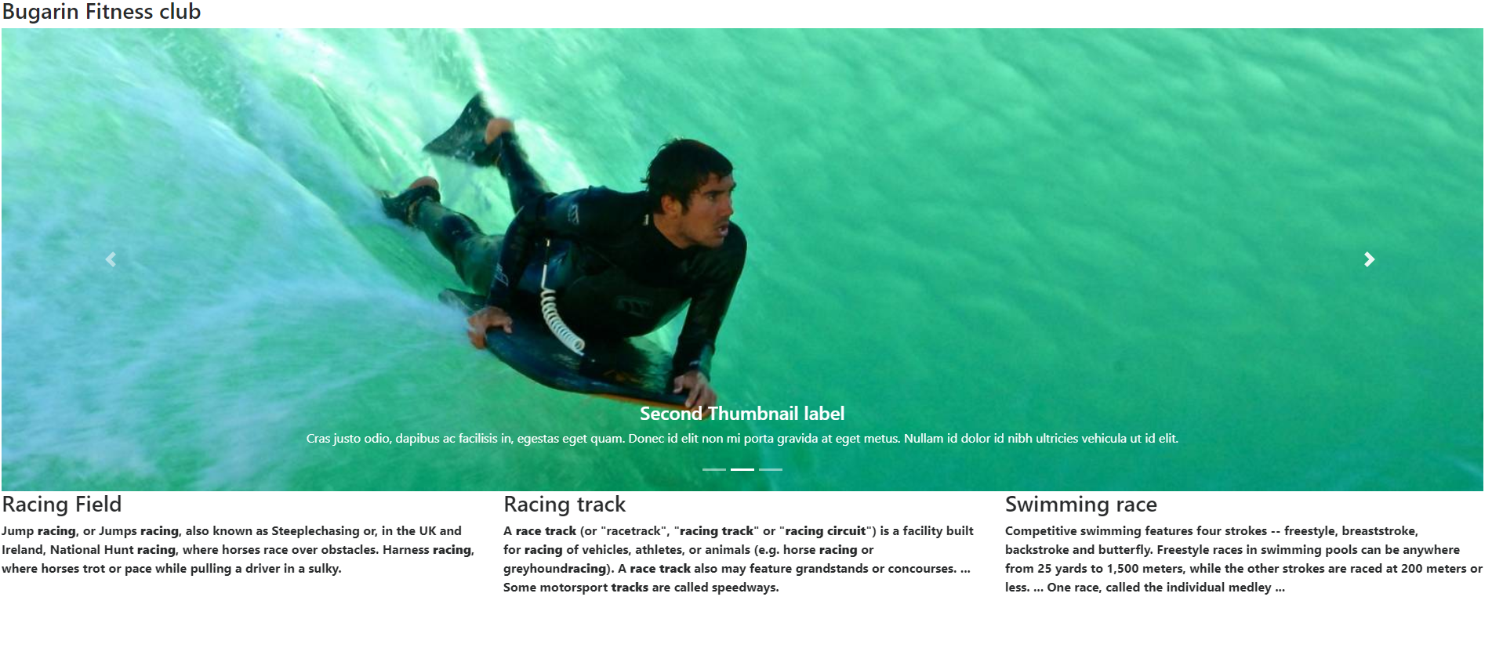

I create this website Bugarin fitness club because to know other people what is the benefits of being in sports and introduce my website to be popular in many people and also to promote healthy livin

g